Introduction to ARM Microcontrollers

**February 9, 2016**

**Team Members:**

Brendan Barry

Tatiana Ensslin

Table of Contents

Introduction 3

Methods 3

Connect Sensor to Microcontroller 3

Read Appropriate Signal 4

Send Data to Desktop PC Using UART 4

Data Obtained Displayed Graphically On PC 4

Results 5

Connect Sensor to Microcontroller 5

Read Appropriate Signal 7

Send Data to Desktop PC Using UART 8

Data Obtained Displayed Graphically On PC 8

Discussion 9

Appendix A – Microcontroller Timers in Output Compare Mode 10

Appendix B – Hello World on the LCD 11

Appendix C – Interfacing a Keypad 16

Appendix D – Reaction Game 19

# Introduction

This lab report presents an application of the Freescale-NXP Kinetis KL05 ARM Cortex M0+ microcontroller along with a USBDM SWD programmer/debugger, how to communicate via I2C, as well as how to interface the microcontroller UART located on an Altera DE2 board. Using timers from the hardware component library in the Kinetis Laboratory program, one is able to learn through this lab how to collect data from an accelerometer programmed to communicate with the microcontroller to collect and then plot values in the x,y, and z direction. This application begins off by connecting the sensor to the microcontroller, reading appropriate signals from the meter to the microcontroller, and then lastly sending data to the desktop using UART and plotting it in Microsoft Excel. By the end of the experiment, one will be able to understand I2C and UART communication on the Kinetis KL05, as well as how to implement other useful components such as the Timer component. One will also become familiar with Kinetis Laboratory and its workspace. All code can be seen in the Appendix.

# Methods

## Connect Sensor to Microcontroller

For this section, we will connect the sensor to the microcontroller by using the Kinetis KL05 to access the accelerometer through the WhoAmI register using I2C Protocol. The WhoAmI register has a hexadecimal return value of 49, which, upon successful communication will display on the logic analyzer (WaveForms program). To begin, we used the Kinetis Laboratory to set the target slave address, which is equal to 29 in decimal. We connect the accelerometer’s pins Vin, GND, SDA, and SCL. The SDA sends/receives the I2C serial data and the SCL is the I2C serial clock. It is important to note that the CS should be set to 1, however on ours it was pull up enabled. We then used Kinetis to set up the master send address as 0x0F –the WhoAmI register address! Also be sure to make modifications to the event.c file as you implement flags throughout the I2C communication for multiple components. Furthermore, we ensured in Kinetis Laboratory that the initial frequency of the microcontroller was set to 20.97152 MHz, and used two dividing registers to get an SCL frequency below 100 KHz. We then used the MasterSend and MasterReceive functions to program the communication between both hardware pieces. Finally, after proper set up and acknowledgements between the microcontroller (master) and the accelerometer/sensor (slave), a successful connection between the master and slave should be implemented.

## Read Appropriate Signal

Next, we begin this section by implementing the TimerInt component, which we make to be a 1ms periodic timer to use before sending and receiving data. We will also program the control register 1. For our target slave address, we set out byte to 01010111 (0x57). After setting the control register 1 to enable the accelerometer values in the x, y, and z direction, we ran our modified Kinetis Laboratory code with interrupts. After continuing the use of I2C and its acknowledgments, along with the TimerInt component, it should be possible to read the appropriate values from the sensor in RealTerm and even prove it using the debugger tool in Kinetis Laboratory.

## Send Data to Desktop PC Using UART

For this section, we created a UART component in Kinetis Laboratory to allow for the sending of our data to connect and to send to RealTerm with a baud rate of 9600. Implement a bit of VHDL (an entity/architecture pair) to allow for the flow of data to come from the sensor, to the PC (RealTerm). This will allow for the receiving of data from the microcontroller to be transmitted to the RealTerm program. It includes two in/out pairs. Next, write code in the Kinetis Laboratory for the UART send commands. In order to get proper data, note that in the MasterSendBlock() the function calls for a pointer of an array, not the address of the array, which if inputted wrong can send improper data. Note that to get a ‘,’ between all three dimensional values, as well as a new line after three values were sent, we used the sprint() function. This was also useful for converting the retrieved values into characters, which also requires the use of all the registers. Note that the TX light on the Altera board blinks green when properly sending data.

## Data Obtained Displayed Graphically On PC

For this section, use RealTerm to capture the data running from the Kinetis Laboratory code. Clear the screen and start capture mode on RealTerm. Begin running the code and allow for a few seconds of data to send to RealTerm. Cease code and capture mode and output save the file to the working directory in RealTerm. Go into the directory and change the extension to .csv for use on Microsoft Excel. Load the file into Excel and select a column (x, y, or z) coordinates and select for a chart to be created as a representation of each coordinate value. Plot these charts over time.

# Results

## Connect Sensor to Microcontroller

This section will focus on Output Compare Mode—also know as wasting an exact amount of time. This may be used to connect the Timer Unit Hardware directly to an I/O pin. On the HCS12, the I/O Port T can control the timer. The timer can also be implemented apart from I/O. There are two registers in the Timer Hardware Unit. They are the timer counter resiter (TCNT) and the output compare registers (TCx). There are 8 output compare registers (TC0-TC7), meaning 8 timers can be implemented at a time. When TCNT equals TCx, a flag is set. The steps we used in implementing the timer is as follows:

* Set up the timer by writing to the timer control registers at the beginning of the program.
* Read the 16-bit timer counter register TCNT and add a delay.
* Place the result into the output compare register TCx.
* As an example: TC2 = TCNT + 0x3A58, which configured a delay of 14,936 timer counts on timer 2.
* Wait for the flag to be set. While(!TFLG1_C2F).
* Take note that when creating a repeating delay, the delay should be added to the output compare register. TC2=TC2+ 0x3A58. This will eliminate any timing errors that will be associated with overhead due to software delays.

We configured the timer to create a square wave in 26Hz. First, we set the I/O pin to enable the data direction and then we configured the timer to automatically flip the I/O pin using the toggle option. The frequency will be verified via the oscilliscope. To find the delay in time for the 26Hz:

6x106 / 128 = 46875Hz 46875Hz/26Hz = 1802.9 1802.9/2 = 0x386 (note: 128 is prescale: 111)

SPEEDUP-Note that because its software, when the program is halted, the square wave should stop entirely. In comparison to hardware, where the wave will continue slowed down.

To speed up to 100kHz:

6x106 / 100kHz = 60 60/2=30 with no prescale. This correlates to about 9.96 micro seconds.

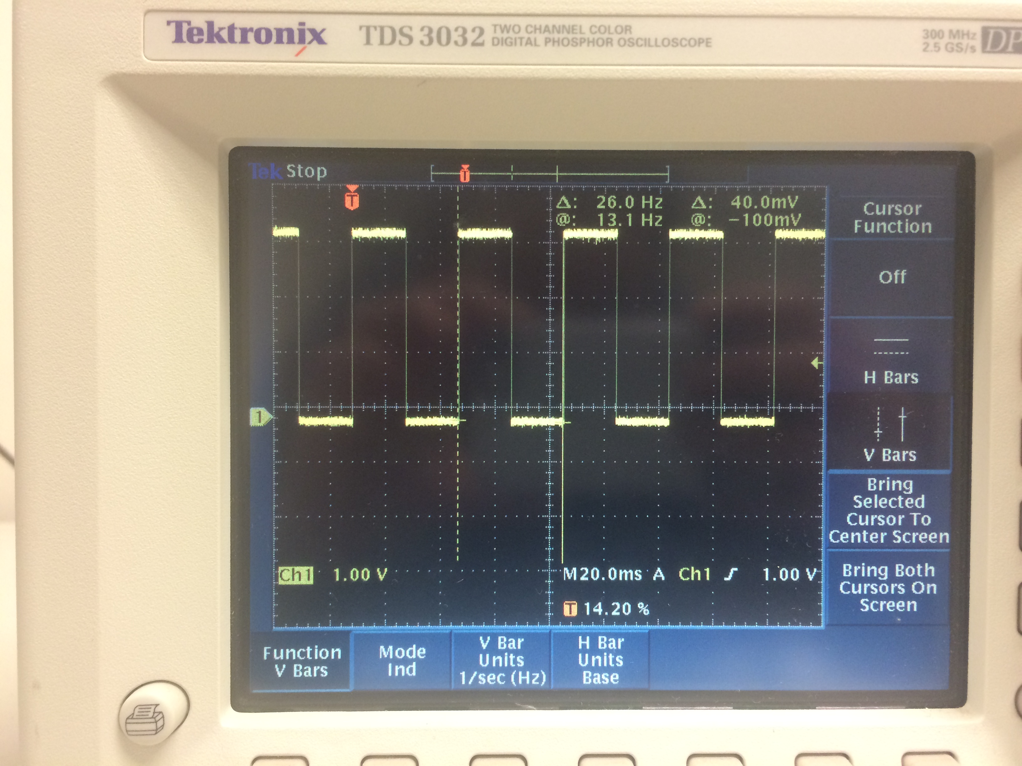

To the left is the software created square wave going at 26Hz.

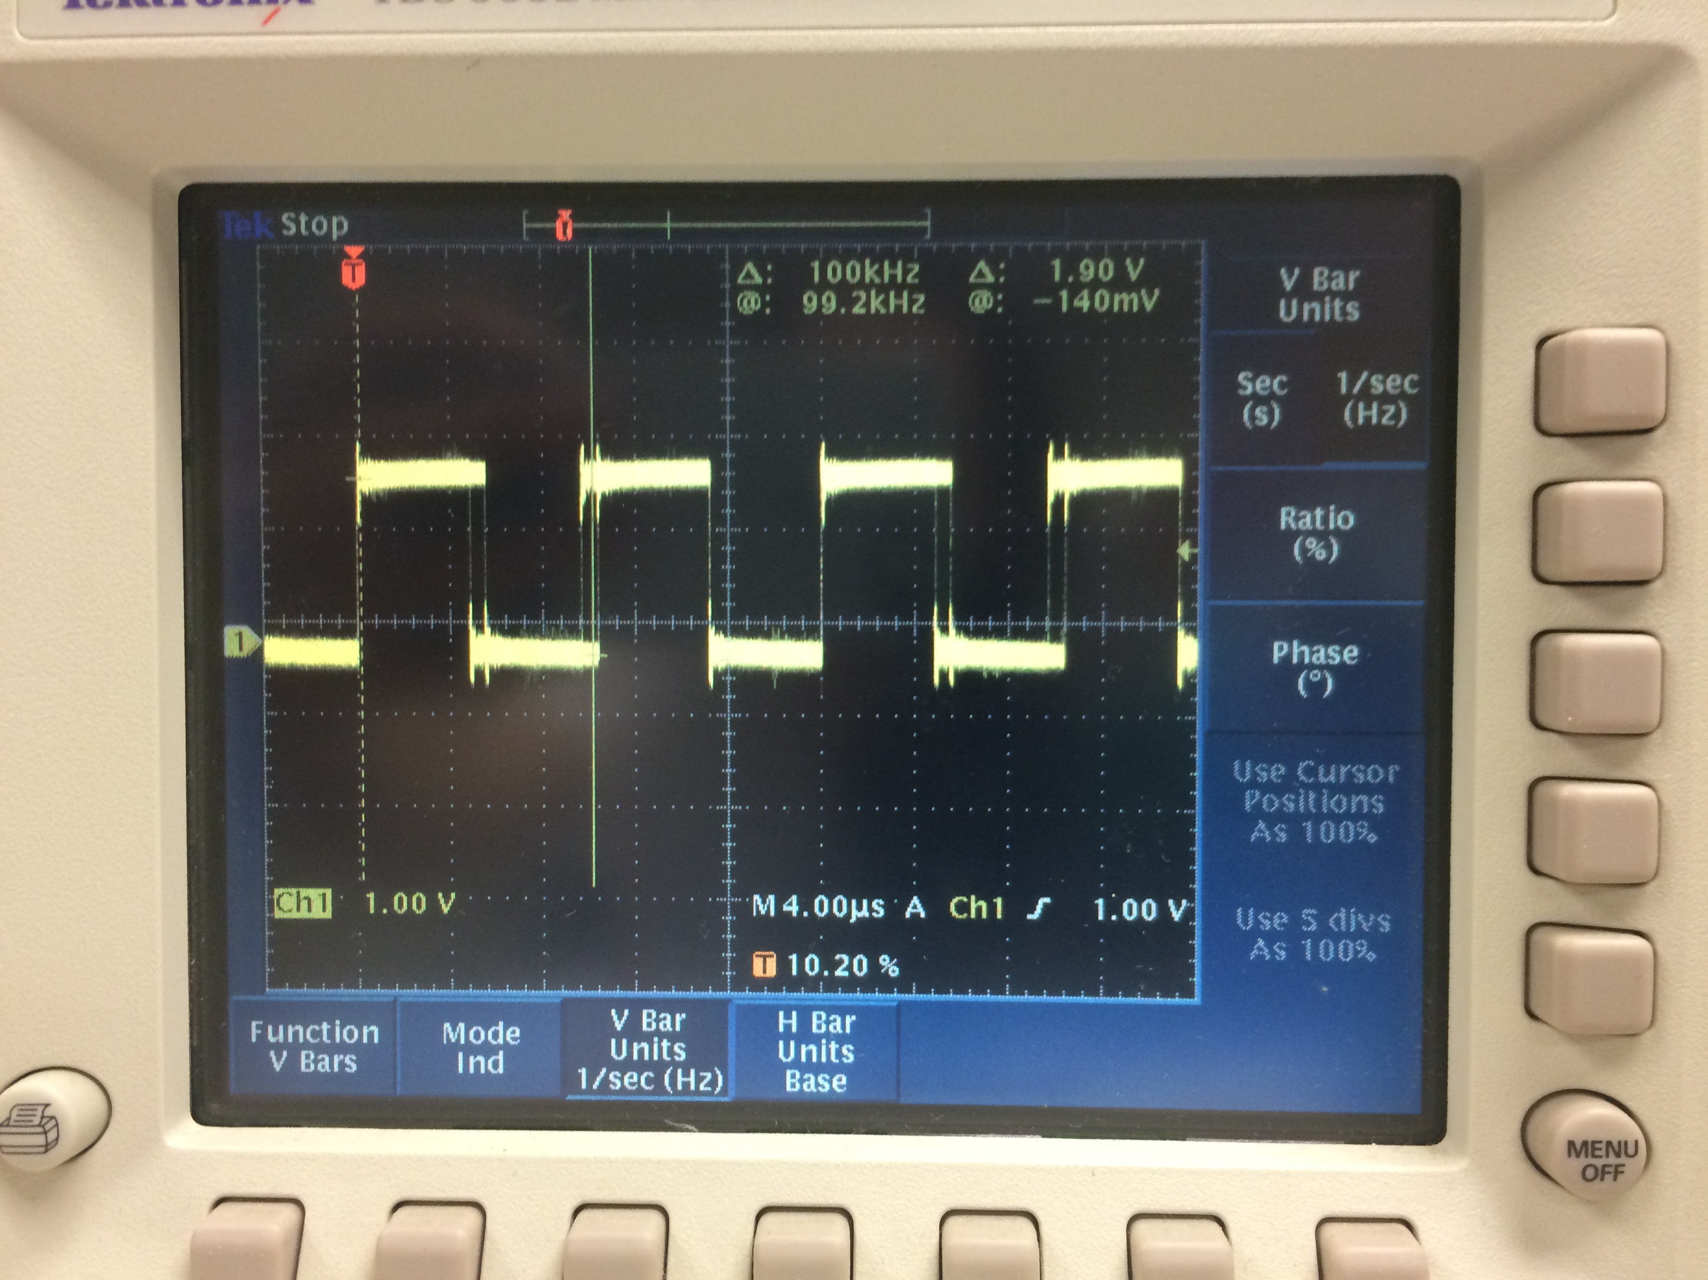

To the right is the software created square wave going at a speed of 100kHz. Note the jitter on the wave.

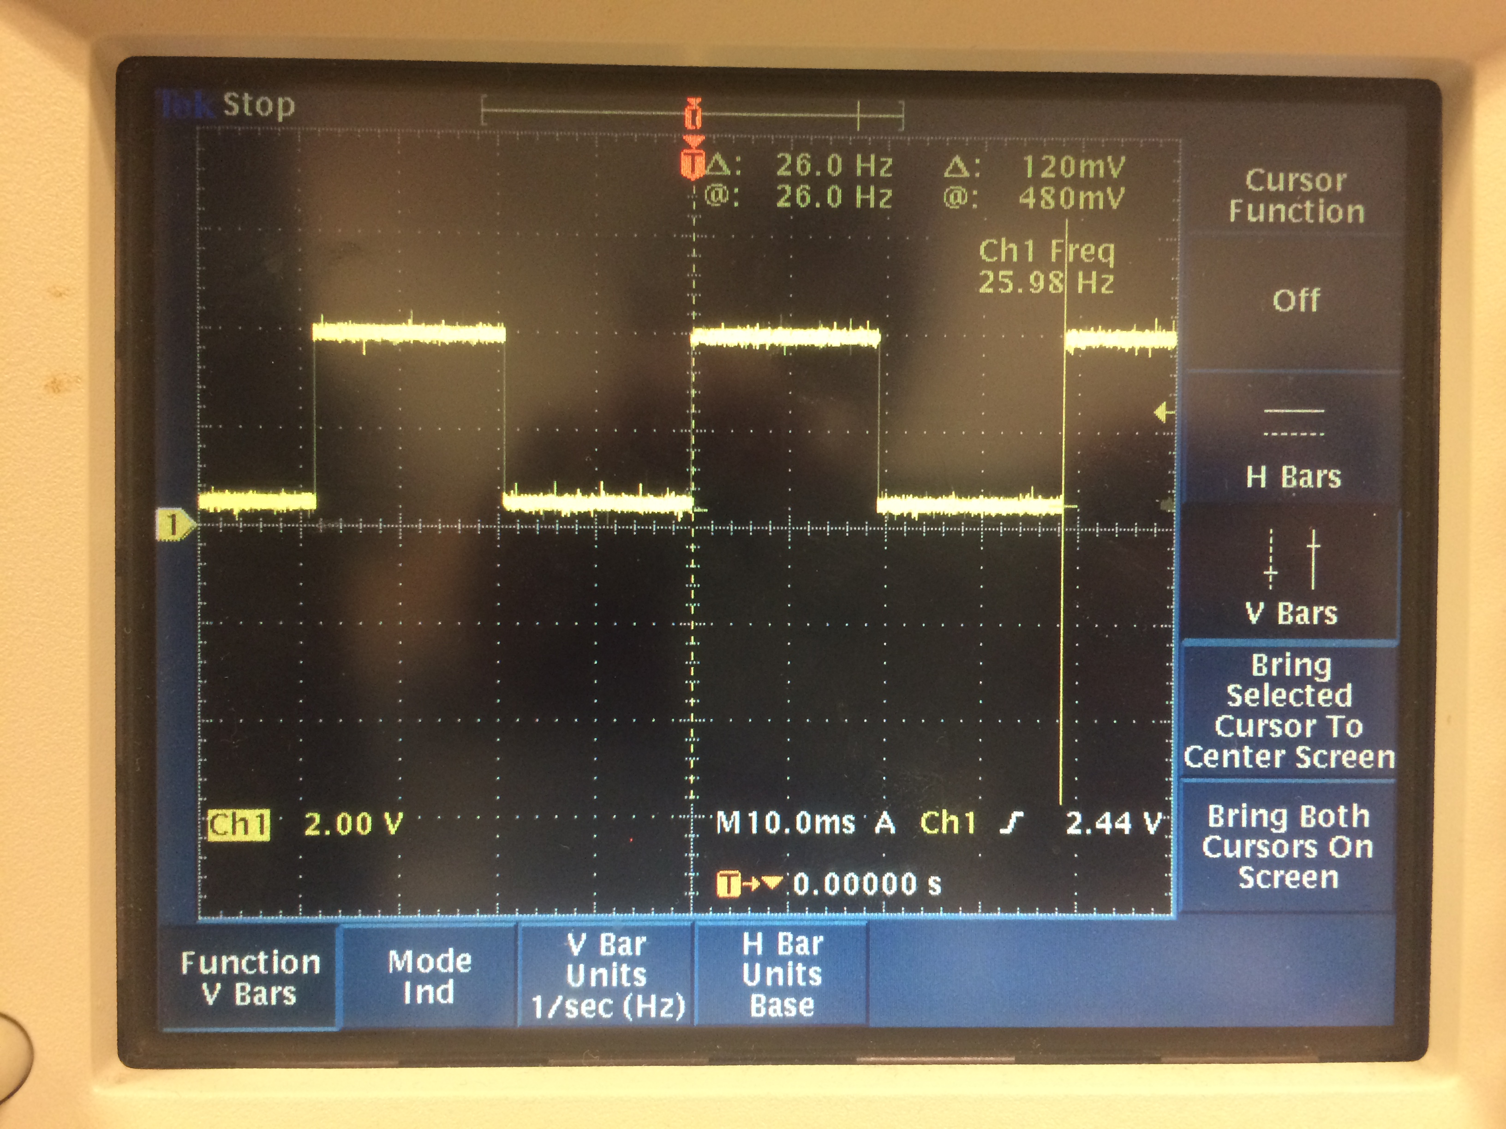

To the left is the 26Hz square wave created through the hardware

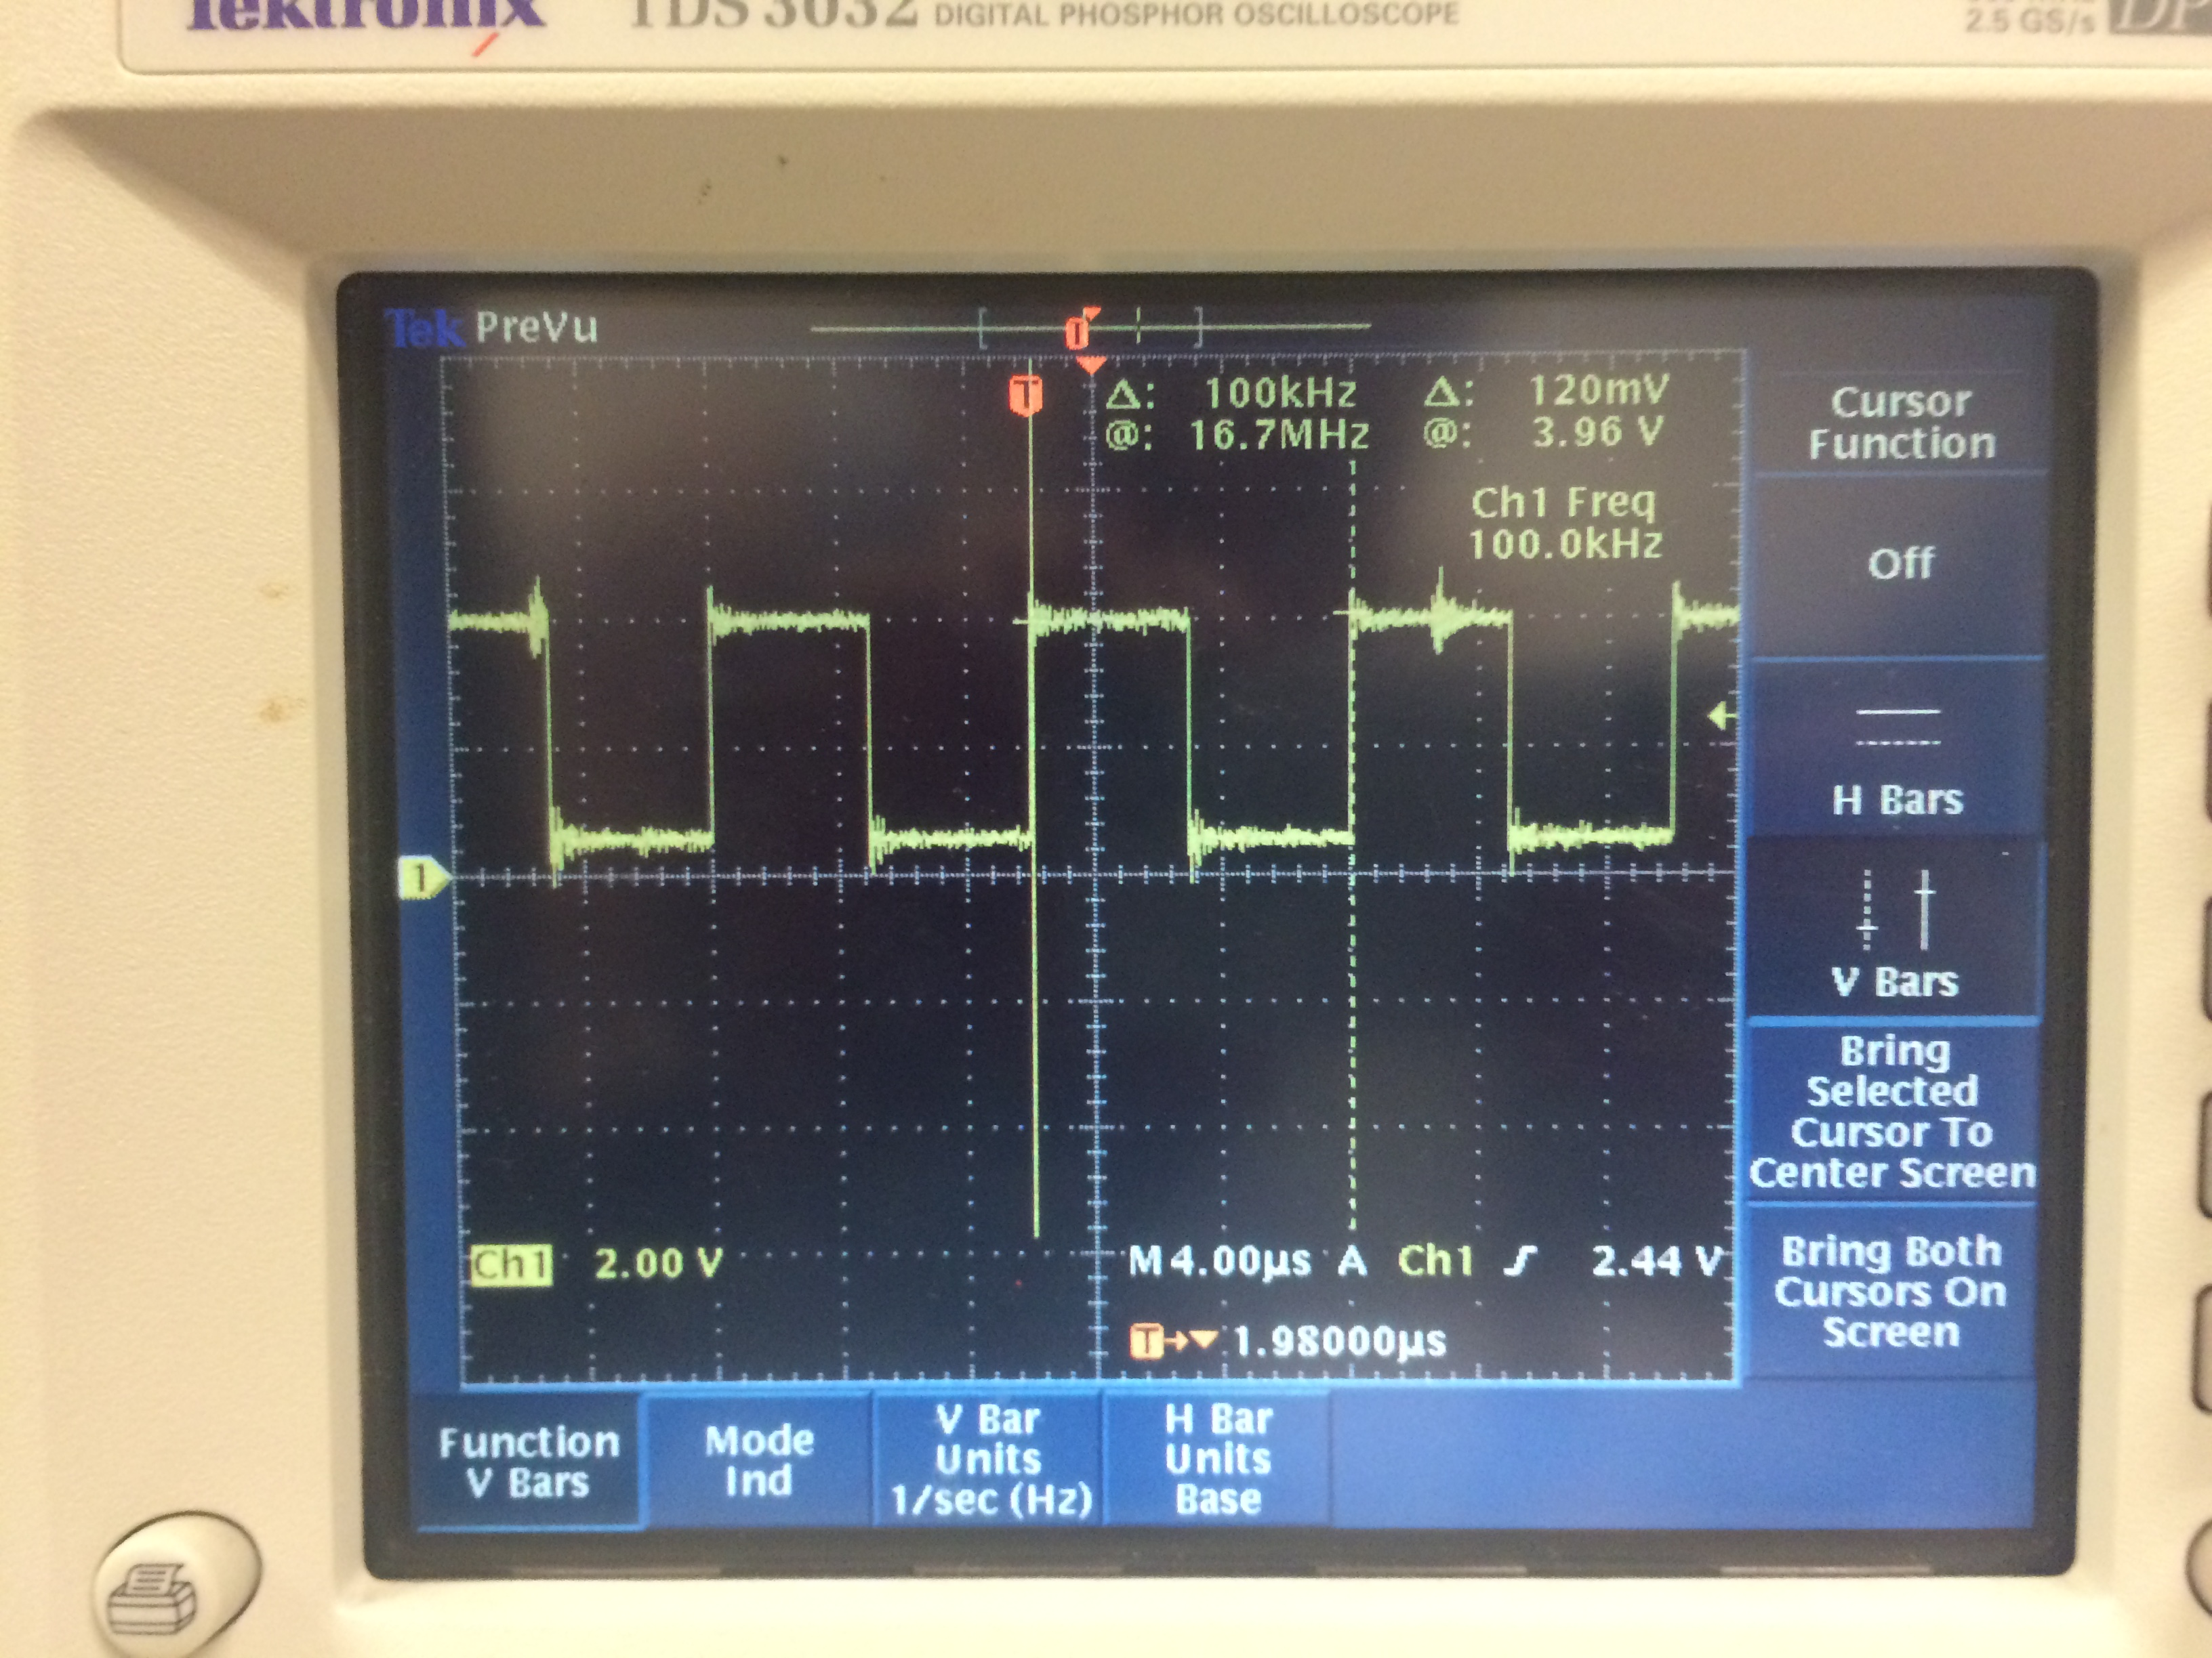To the rigth is the 100kHz square wave created by the hardware. Note the jitter on the wave.

Note the jitter which can be seen on the faster 100kHz square waves. Also, it is important to mention that we had to set the prescaler to divide by 128 for our delay time to accurately slow down the frequency on the 26Hz . The prescaler was removed for the 100kHz frequency. The code for this section can be found in the appendix.

## Read Appropriate Signal

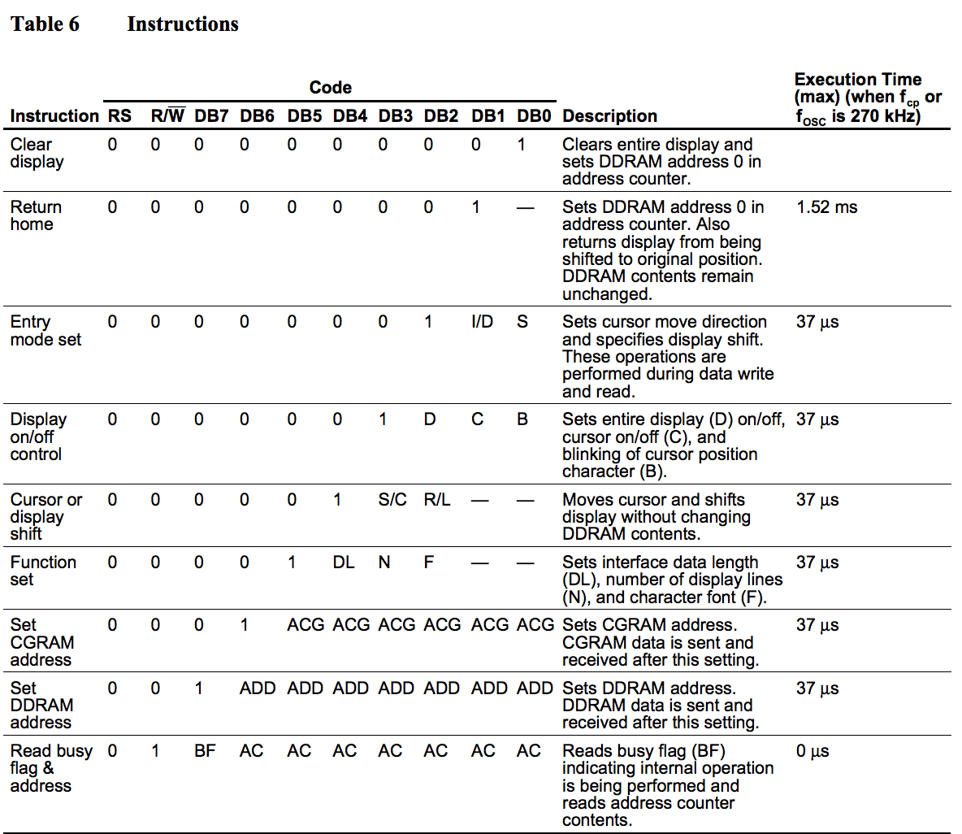 The LCD is located on the Altera DE2 board. We will create a small VHDL circuit that simple connects the LCD pins to the 40-pin header. This will allow us to control the LCD using the HCS12 microcontroller. Using interfacing information about the LCD, we will write a small piece of software that will display “Hello World” on the LCD. In order to make sure we can format the LCD screen, we will display Hello World left justified, along with showing Tatiana and GX centered on the second line. We set two P Ports and 8 AD ports for this section. We will use the timer and set it to 90 for a 49 microsecond delay, and 300 for a 1.65ms delay. This means we need to keep the prescale set to all 0’s. There are two outputs we will be coding on the Altera in VHDL, the LCD_ON and LCD_RW. Table 6 (seen right) on the LCD microcontroller’s data sheet contains the list of signals that can be used to send instructions to the LCD. We will use its 8-bit mode. The process of sending our data to the LCD is as follows: Connect power. Set function set (tells what bits to set). Display on control (set to enable). Set entry mode to 8-bits. Write data in ASCII. Set DDR address (this shifts the cursor to the second line at address 0x064 (if set to that address)). We use VHDL code with 11 inputs and 11 outputs. This will allow us to connect the 40-pin header to our LCD display. To center the 40-Pin header to out LCD display we sent the function set, display control, entry mode set, writing “Hello World”, then setting the DDR address instruction. We used 0xC4 to center our names (position) them on the second line. Our finished result can be viewed below. The code for this section can be found in the appendix.

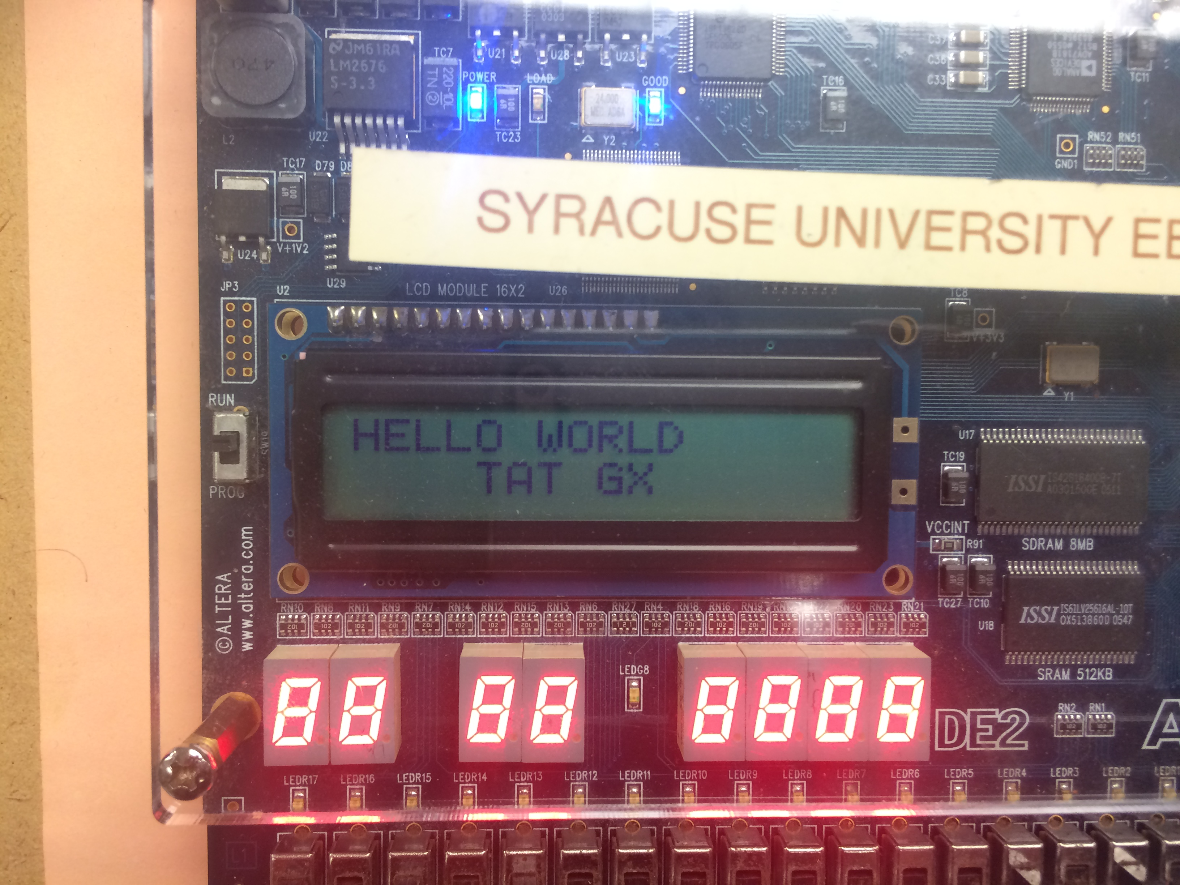

## Send Data to Desktop PC Using UART

We were given a 4x4 keypad, which is simply 16 switches connected by 8 wires. We will create an algorithm that will implement knowing the pressed button and display it to the LCD. The back of the keypad looks like:

We will have four inputs and four outputs. We will also set a pull enable and polarity register on our ports in order for all the ports to be initialized to ‘0’. Our algorithm will register a ‘1==1,’ which will then print that selected character. We will use an 8-pin header to connect the keypad to our controller. To do this, we set OCPD (enable T ports for non-timer use) to 0xFF and use the T ports to connect the keypad. We will set our rows as out and our columns as in. T0-T3

1 2 3 A

4 5 6 B

7 8 9 C

* 0 # D

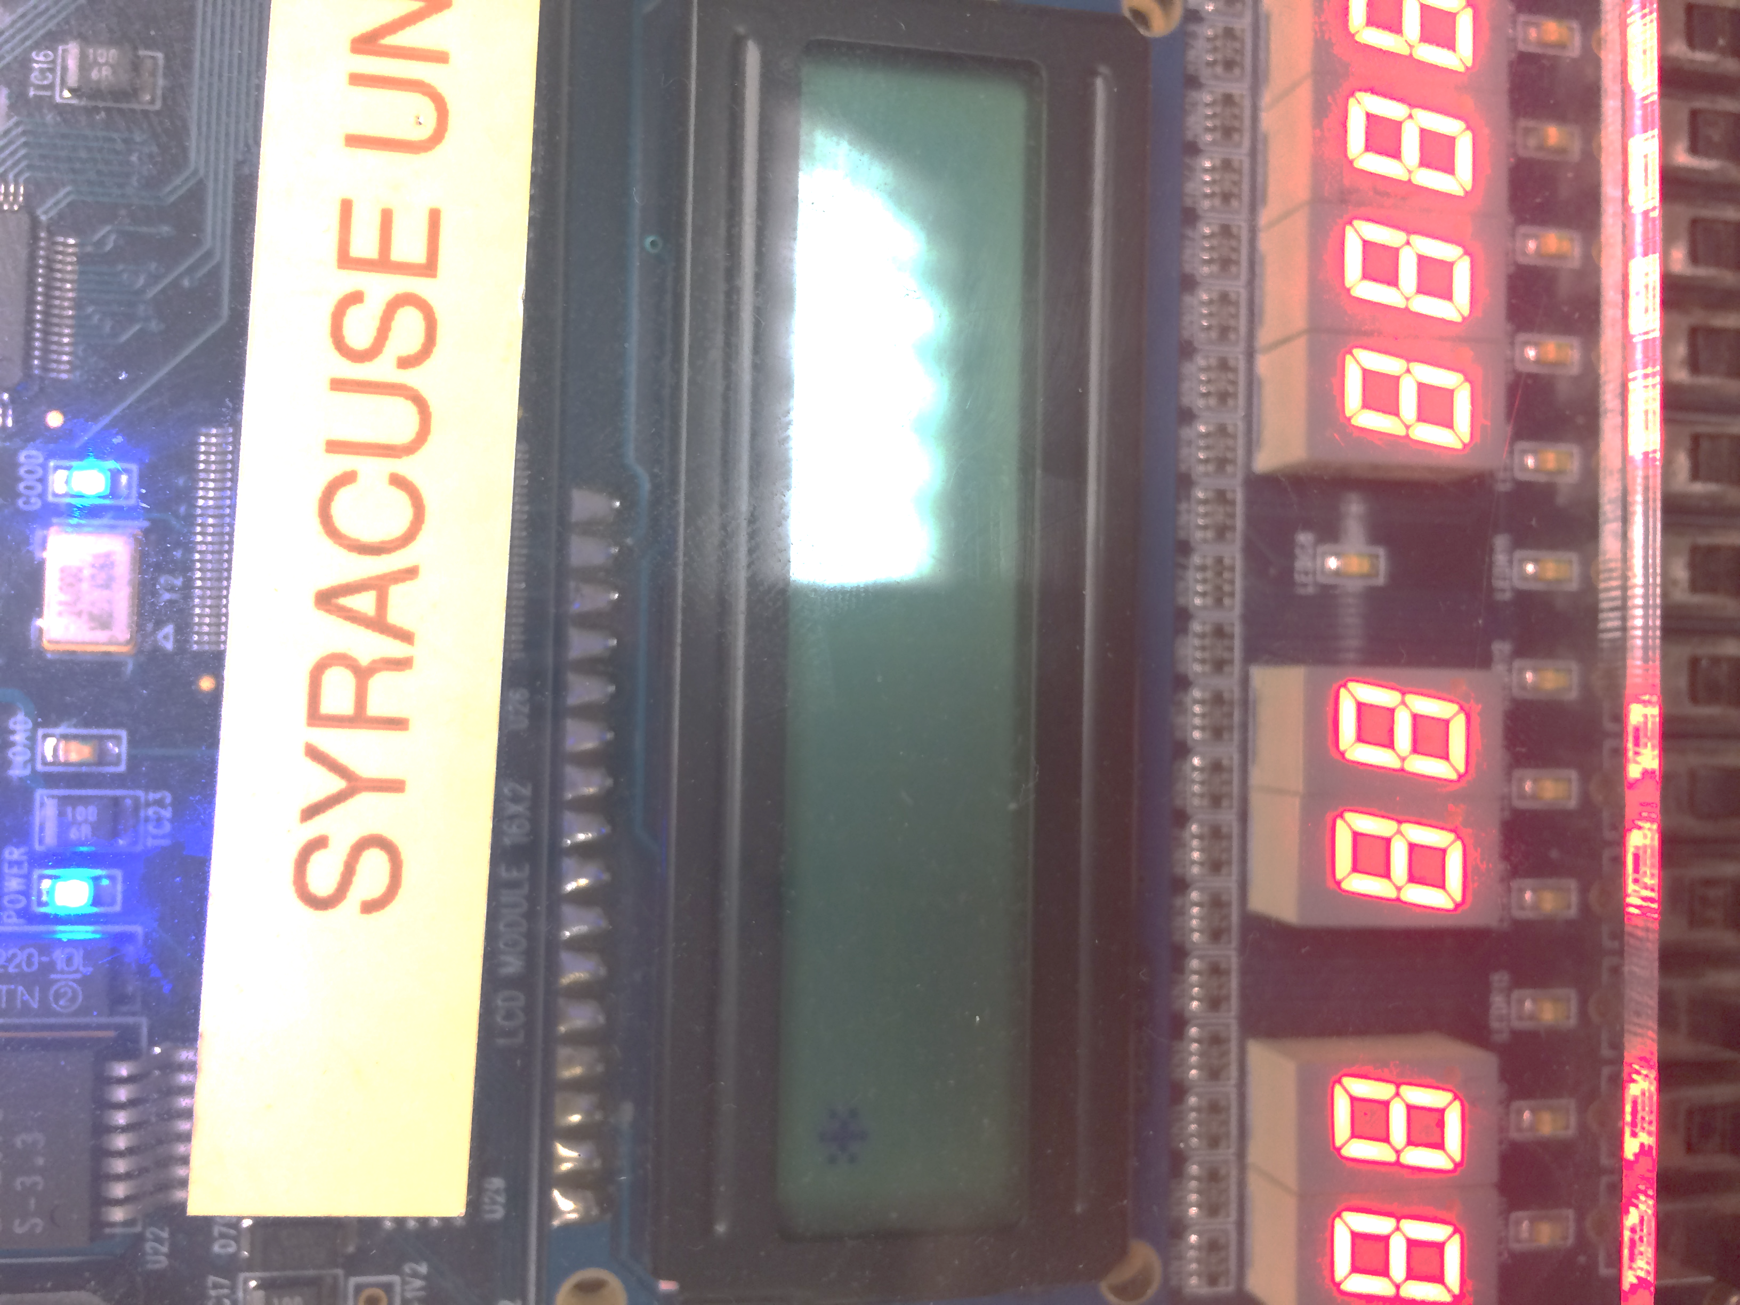are outputs and T4-T7 are our inputs. We now enable the pull registers, which will set all the T ports to ‘0.’ We also created multiple functions to clean and ease the code, such as an enable function which sets the enable bit to ‘1’ then ‘0,’ a cleardisplay function, as well as a writedata function which intakes a character to be printed out. These functions and others include a special delay calculated for the keypad between buttons. Our VHDL code remained the same from the last part. Note that in our code, we clear the LCD screen before changing to the next character. When using the keypad, the wires can have bounce, which is due to the 8 wires crossing unintentionally when a button is pressed. This can be resolved through a small delay, which allows for the full ‘1’ of the button press to be registered. The code for this section can be found in the appendix.

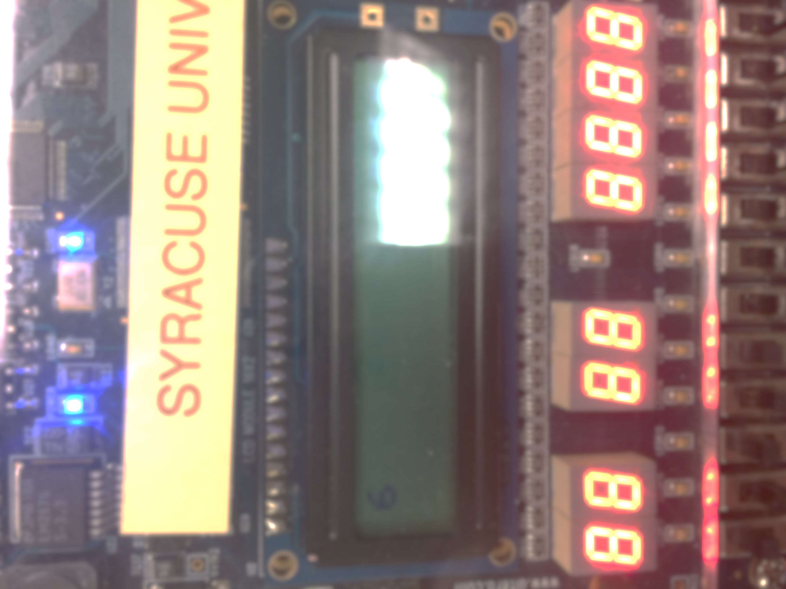

To the left are screenshots of two of the characters being displayed properly on the LCD display after being pressed on the keypad.

## Data Obtained Displayed Graphically On PC

This game started by displaying “Press any key to begin.” When a key on the keypad is pressed the program should clear the screen and then display two of the 16-keypad characters randomly on the first line of the LCD. The user will then press the two characters. Upon correct input, the microcontroller will then capture the keys and display the time between the last character displayed on the LCD and the last character pressed on the keypad. The time will then display on the second line of the LCD to the nearest ms, saying “Reaction xxx ms.” The game should reset after a 5-10 second delay. For the counter, we set TCNT to a variable and when the two buttons are finished being properly inputted, saved TCNT to another variable. We then found the difference from those variables. After, we converted this difference to milliseconds and then to seconds (x1000), and the frequency to time/clock cycles. 1/6,000,000 is the time for 1 clock cycle. 216 (size of TCNT) –1/6,000,000. Therefore, with our timer prescaler, we divide the reaction time x1000 by 46875 to get out time to display in ms. After this, we get the time that we would like to display on the LCD, however, in order for it to be displayed, it needs to be modded by 10 in order to be split up by places to be printed because the number is longer than 1 character. Unfortunately, due to a byte compile error restriction, we were unable to debug past this stage in our code and completed the remainder of the section. We tried splitting the code into a .h and .c file, and creating a new project to load them in, however we encountered link errors when trying to do so. Although we were unable to finish, you can see out unfinished code in the appendix.

# Discussion

This lab has provided us with a good understanding of what a microcontroller is capable of doing through its ports and with its timer hardware component. The timer Output Compare Mode, is extremely useful in being able to communicate with the LCD display, for it allows us to insert delays between instructions being sent to the LCD microcontroller. Once again, we learn that the microcontroller has multiple capabilities for communication protocols that can be useful when programming a complex device/project. The microcontroller itself contains several programmable registers, which allow the microcontroller to preform different actions on its ports. This principle is apparent in and throughout this lab. We used the Port T in the beginning as a I/O for the timer’s output compare, however, we broke it off of the hardware and used it in the third section to program the keypad in conjunction with the microcontroller and the LCD display. We used all 8 AD Ports in the second section to connect the LCD display to the microcontroller, as well as using two M Ports in order to control the instructions being sent over to the LCD display. The most difficult part of this experiment was being able to distinguish the prescaler’s size in order to accurately get the precise time needed for each function to allow it to implement to the best performance. Additionally, it was extremely frustrating to experience a delay that was too long on the keypad’s algorithm and see how it created a delay on the LCD display. Through trial and error, we were eventually able to figure out the cause of our errors in our timing by using the debugging tool to correctly identify the proper registers and logic to successfully complete the section. Lastly, although we were unable to finish the reaction game in the last section, we were able to complete most of it and realize that section truly tested our knowledge of being able to use the timer hardware, as well as properly implement the logic to create a working game. Unfortunately, because of the byte limit, our design was really pressured to take strange shapes, and then eventually unable to even be completed. Although we couldn’t finish, to see how to interface the keypad in terms with both the LCD’s microcontroller and the HCS12 microcontroller, this experiment was by far one of the best of the semester.

Although we did encounter a few challenges while working through this lab, such as selecting incorrect registers to program, or picking an un-programmable port (in our Hello World section, we used the T ports originally, which caused an interference with the timer, which was using the port T0), our initial approach to implementing the microcontroller’s hardware unit in terms with external hardware was primarily correct. Through use of the datasheet, header file in the CodeWarrior, and knowledge about the communication protocols for both microcontrollers, we found the use of the timer hardware component to be critical to being able to fully implement larger projects and experiments.

# Appendix A – Microcontroller Timers in Output Compare Mode

Software SLOW (26Hz):

#include <hidef.h> /* common defines and macros */

#include "derivative.h" /* derivative-specific definitions */

void main(void) {

TIOS_IOS0 = 1; //enable output compare for timer0

TSCR1_TEN = 1; //enable main counter/timer

TSCR1_TFFCA = 1; //enable flag to clear

TSCR2_PR0=1; // divide the prescaler 128

TSCR2_PR1=1;

TSCR2_PR2=1;

OCPD = 1;

TC0=TCNT + 0x386; //26Hz in clock cycles

DDRT_DDRT0 =1;

PTT_PTT0 =1;

while(1){

TC0=TC0 + 0x386;

while(!TFLG1_C0F){}

PTT_PTT0 =!PTT_PTT0;

}

}

Software FAST (100kHz):

#include <hidef.h> /* common defines and macros */

#include "derivative.h" /* derivative-specific definitions */

void main(void) {

TIOS_IOS0 = 1; //enable output compare for timer0

TSCR1_TEN = 1; //enable main counter/timer

TSCR1_TFFCA = 1; //enable flag to clear

TSCR2_PR0=0; // divide the prescaler 128

TSCR2_PR1=0;

TSCR2_PR2=0;

OCPD = 1;

TC0=TCNT + 30; //26Hz in clock cycles

DDRT_DDRT0 =1;

PTT_PTT0 =1;

while(1){

TC0=TC0 + 30;

while(!TFLG1_C0F){}

PTT_PTT0 =!PTT_PTT0;

}

}

Hardware SLOW (26Hz):

#include <hidef.h> /* common defines and macros */

#include "derivative.h" /* derivative-specific definitions */

void main(void) {

TIOS_IOS0 = 1; //enable output compare for timer0

TSCR1_TEN = 1; //enable main counter/timer

TSCR1_TFFCA = 1; //enable flag to clear

TTOV_TOV0 = 0x01;

TCTL1_OL4 = 1;

TCTL1_OL5 = 1;

TCTL1_OL6 = 1;

TCTL1_OL7 = 1;

TCTL2_OL0 = 1;

TCTL2_OL1 = 1;

TCTL2_OL2 = 1;

TCTL2_OL3 = 1;

TSCR2_PR0=1; // divide the prescaler 128

TSCR2_PR1=1;

TSCR2_PR2=1;

TC0=TCNT + 0x386; //26Hz in clock cycles

DDRT_DDRT0 =1;

PTT_PTT0 =1;

while(1){

TC0=TC0 + 0x386;

while(!TFLG1_C0F){}

}

}

Hardware FAST (100kHz):

#include <hidef.h> /* common defines and macros */

#include "derivative.h" /* derivative-specific definitions */

void main(void) {

TIOS_IOS0 = 1; //enable output compare for timer0

TSCR1_TEN = 1; //enable main counter/timer

TSCR1_TFFCA = 1; //enable flag to clear

TSCR2_PR0=0; // divide the prescaler 128

TSCR2_PR1=0;

TSCR2_PR2=0;

OCPD = 1;

TC0=TCNT + 30; //26Hz in clock cycles

DDRT_DDRT0 =1;

PTT_PTT0 =1;

while(1){

TC0=TC0 + 30;

while(!TFLG1_C0F){}

PTT_PTT0 =!PTT_PTT0;

}

}

# Appendix B – Hello World on the LCD

#include <hidef.h> /* common defines and macros */

#include "derivative.h" /* derivative-specific definitions */

void enable();

void main(void) {

DDR1AD0=0XFF;

DDRM_DDRM2=1;

DDRM_DDRM3=1;

//Timer Initializations

TIOS=0XFF;

TCTL2=0X10;

TSCR1_TEN=1;

TSCR1_TFFCA=1;

DDRT=0xFF;

TSCR2=0x03;

OCPD_OCPD2=1;

TC0=TCNT + 300; //49mic delay

while(!TFLG1_C0F){}

TC0=TCNT + 300; //49mic delay

while(!TFLG1_C0F){}

//clear screen

PT1AD0=0X01;//CLEAR DISPLAY

PTM_PTM3=0; // RS

PTM_PTM2=1; // SELECT DATA

PTM_PTM2=0;

TC0=TCNT + 300; //49mic delay

while(!TFLG1_C0F){}

TC0=TCNT + 300; //49mic delay

while(!TFLG1_C0F){}

TC0=TCNT + 300; //49microsecond delay

//functon set

PT1AD0 = 0x3F;

PTM_PTM3 = 0;

enable();

TC0=TCNT + 300; //49mic delay

while(!TFLG1_C0F){}

//display on

PT1AD0 = 0x0E;

PTM_PTM3 = 0;

enable();

TC0=TCNT + 300; //49mic delay

while(!TFLG1_C0F){}

//entry mode

PT1AD0 = 0x06;

PTM_PTM3 = 0;

enable();

TC0=TCNT + 300; //49mic delay

while(!TFLG1_C0F){}

TC0=TCNT + 300; //49mic delay

while(!TFLG1_C0F){}

//write data

PT1AD0 = 'H';

PTM_PTM3 = 1;

enable();

TC0=TCNT + 300; //49mic delay

while(!TFLG1_C0F){}

//write data

PTM_PTM3 = 1;

PT1AD0 = 'E';

enable();

TC0=TCNT + 300; //49mic delay

while(!TFLG1_C0F){}

//write data

PTM_PTM3 = 1;

PT1AD0 = 'L';

enable();

TC0=TCNT +300; //49mic delay

while(!TFLG1_C0F){}

//write data

PTM_PTM3 = 1;

PT1AD0 = 'L';

enable();

TC0=TCNT + 300; //49mic delay

while(!TFLG1_C0F){}

//write data

PTM_PTM3 = 1;

PT1AD0 = 'O';

enable();

TC0=TCNT + 300; //49mic delay

while(!TFLG1_C0F){}

//write data

PTM_PTM3 = 1;

PT1AD0 = ' ';

enable();

TC0=TCNT + 300; //49mic delay

while(!TFLG1_C0F){}

//write data

PTM_PTM3 = 1;

PT1AD0 = 'W';

enable();

TC0=TCNT + 300; //49mic delay

while(!TFLG1_C0F){}

//write data

PTM_PTM3 = 1;

PT1AD0 = 'O';

enable();

TC0=TCNT + 300; //49mic delay

while(!TFLG1_C0F){}

//write data

PTM_PTM3 = 1;

PT1AD0 = 'R';

enable();

TC0=TCNT + 300; //49mic delay

while(!TFLG1_C0F){}

//write data

PTM_PTM3 = 1;

PT1AD0 = 'L';

enable();

TC0=TCNT + 300; //49mic delay

while(!TFLG1_C0F){}

//write data

PTM_PTM3 = 1;

PT1AD0 = 'D';

enable();

TC0=TCNT + 300; //49mic delay

while(!TFLG1_C0F){}

TC0=TCNT + 300; //49mic delay

while(!TFLG1_C0F){}

//set DDRAM

PT1AD0 = 0xC4; //set to 1st line far left

PTM_PTM3 = 0;

enable();

TC0=TCNT + 300; //49mic delay

while(!TFLG1_C0F){}

//write data

PT1AD0 = 'T';

PTM_PTM3 = 1;

enable();

TC0=TCNT + 300; //49mic delay

while(!TFLG1_C0F){}

//write data

PTM_PTM3 = 1;

PT1AD0 = 'A';

enable();

TC0=TCNT + 300; //49mic delay

while(!TFLG1_C0F){}

//write data

PTM_PTM3 = 1;

PT1AD0 = 'T';

enable();

TC0=TCNT + 300; //49mic delay

while(!TFLG1_C0F){}

//write data

PTM_PTM3 = 1;

PT1AD0 = ' ';

enable();

TC0=TCNT + 300; //49mic delay

while(!TFLG1_C0F){}

//write data

PTM_PTM3 = 1;

PT1AD0 = 'G';

enable();

TC0=TCNT + 300; //49mic delay

while(!TFLG1_C0F){}

//write data

PTM_PTM3 = 1;

PT1AD0 = 'X';

enable();

TC0=TCNT + 300; //49mic delay

while(!TFLG1_C0F){}

while(1){

}

}

void enable(){

PTM_PTM2 = 1; //this is the enable for the LCD

PTM_PTM2 = 0; //this is the enable for the LCD

}

=============================================

library IEEE;

use IEEE.std_logic_1164.all;

use IEEE.std_logic_unsigned.all;

entity LCD is

port (

t0 : in std_logic;

t1 : in std_logic;

t2 : in std_logic;

t3 : in std_logic;

t4 : in std_logic;

t5 : in std_logic;

t6 : in std_logic;

t7 : in std_logic;

p0 : in std_logic;

outa : out std_logic;

outb : out std_logic;

outc : out std_logic;

outd : out std_logic;

oute : out std_logic;

outf : out std_logic;

outg : out std_logic;

outh : out std_logic;

out1 : out std_logic;

enable : in std_logic;

LCDon : out std_logic;

out2 : out std_logic;

out3 : out std_logic

);

end entity;

architecture behave of LCD is

BEGIN

LCDon <= '1';

out3 <= enable; --P1

out1 <= p0; --RS

out2 <= '0'; --rw

outa <= t0; --hex byte

outb <= t1;

outc <= t2;

outd <= t3;

oute <= t4;

outf <= t5;

outg <= t6;

outh <= t7;

end architecture;

# Appendix C – Interfacing a Keypad

#include <hidef.h> /* common defines and macros */

#include "derivative.h" /* derivative-specific definitions */

void enable();

void writeData(unsigned char letter);

void clearDisplay();

void Delay();

void main(void) {

// port initializations

DDR1AD0=0xFF;

DDRM_DDRM2=1;

DDRM_DDRM3=1;

DDRT=0xF0; //set t0-t3 as inputs and t4-t7 as outputs

PERT = 0x0F; //set the pull enable all to 0

PPST = 0x0F; //polarity

OCPD=0xFF; //enable T ports as i/o

//Timer Initializations

TIOS=0xFF;

TCTL2=0x10;

TSCR1_TEN=1;

TSCR1_TFFCA=1;

TSCR2=0x03;

//send beginning instructions

clearDisplay();

while(!TFLG1_C0F){}

TC0=TCNT + 300; //49microsecond delay

//functon set

PT1AD0 = 0x3F;

PTM_PTM3 = 0;

enable();

TC0=TCNT + 300; //49mic delay

while(!TFLG1_C0F){}

//display on

PT1AD0 = 0x0E;PTM_PTM3 = 0;

enable();

TC0=TCNT + 300; //49mic delay

while(!TFLG1_C0F){}

//entry mode

PT1AD0 = 0x06;

PTM_PTM3 = 0;

enable();

TC0=TCNT + 300; //49mic delay

while(!TFLG1_C0F){}

TC0=TCNT + 300; //49mic delay

while(!TFLG1_C0F){}

// end beginning instructions

//=================================================================

//algorithm to recognize letter

int i =0;

for(;;){

for(int i = 0; i <4; i++){

if(i==0){

PTT_PTT4=1;

PTT_PTT5=0;

PTT_PTT6=0;

PTT_PTT7=0;

Delay();

if(PTT_PTT0==1) {

clearDisplay();

writeData(0x44); //1

}

Delay();

if(PTT_PTT1==1) {

clearDisplay();

writeData(0x23); //4

}

Delay();

if(PTT_PTT2==1) {

clearDisplay();

writeData(0x30); //7

}

Delay();

if(PTT_PTT3==1) {

clearDisplay();

writeData(0x2A); //x

}

Delay();

}

if(i==1){

PTT_PTT4=0;

PTT_PTT5=1;

PTT_PTT6=0;

PTT_PTT7=0;

if(PTT_PTT0==1) {

clearDisplay();

writeData(0x43);//send 2

}

if(PTT_PTT1==1) {

clearDisplay();

writeData(0x39);//send5

}

if(PTT_PTT2==1) {

clearDisplay();

writeData(0x38);//send8

}

if(PTT_PTT3==1) {

clearDisplay();

writeData(0x37); //send 0

}

}

if(i==2){

PTT_PTT4=0;

PTT_PTT5=0;

PTT_PTT6=1;

PTT_PTT7=0;

if(PTT_PTT0==1) {

clearDisplay();

writeData(0x42);//send 3

}

if(PTT_PTT1==1) {

clearDisplay();

writeData(0x36); //send6

}

if(PTT_PTT2==1) {

clearDisplay();

writeData(0x35);//send9

}

if(PTT_PTT3==1) {

clearDisplay();

writeData(0x34);//send #

}

}

if(i==3){

PTT_PTT4=0;

PTT_PTT5=0;

PTT_PTT6=0;

PTT_PTT7=1;

Delay();

if(PTT_PTT0==1) {

clearDisplay();

writeData(0x41);//send A

}

Delay();

if(PTT_PTT1==1) {

clearDisplay();

writeData(0x33);//sendB

}

if(PTT_PTT2==1) {

clearDisplay();

writeData(0x32);//sendC

}

if(PTT_PTT3==1) {

clearDisplay();

writeData(0x31);//send D

}

}

}

}

}

void clearDisplay(){

TC0=TCNT + 300; //49mic delay

while(!TFLG1_C0F){}

//clear screen

PT1AD0=0X01;//CLEAR DISPLAY

PTM_PTM3=0; // RS

PTM_PTM2=1; // SELECT DATA

PTM_PTM2=0;

}

void enable(){

PTM_PTM2 = 1; //this is the enable for the LCD

PTM_PTM2 = 0; //this is the enable for the LCD

}

void writeData(unsigned char letter){

TSCR2_PR0=0;

TSCR2_PR1=1;

TSCR2_PR2=0;

TC0=TCNT + 6760; //49mic delay

while(!TFLG1_C0F){}

//write data

PTM_PTM3 = 1;

PT1AD0 = letter;

enable();

}

void Delay(){

TSCR2_PR0=0;

TSCR2_PR1=1;

TSCR2_PR2=1;

TC0=TCNT + 0x2497; //delay

while(!TFLG1_C0F){}

}

# Appendix D – Reaction Game

#include <hidef.h> /* common defines and macros */

#include "derivative.h" /* derivative-specific definitions */

void enable();

void writeData(unsigned char letter);

void clearDisplay();

void Delay();

void reposition(unsigned char position); //set DDgram

void writeData2(unsigned char letter);

void run();

void welcome();

void sendInitInstructions();

void generateSecretNumbers();

//void pressAnyButton(); //begins game

void findButton(); //finds and prints when a button is pressed

int num;

int num2;

unsigned char symbols[16]={0x31,0x32,0x33,0x34,0x35,0x36,0x37,0x38,0x39,0x30,0x2A,0x23,0x41,0x42,0x43,0x44};

unsigned char answer1;

unsigned long int time1;

unsigned long int time2;

unsigned long int reactionTime;

unsigned long int a,b,c,d;

void main(void) {

// port initializations

DDR1AD0=0xFF;

DDRM_DDRM2=1;

DDRM_DDRM3=1;

DDRT=0xF0; //set t0-t3 as inputs and t4-t7 as outputs

PERT = 0x0F; //set the pull enable all to 0

PPST = 0x0F; //polarity

OCPD=0xFF; //enable T ports as i/o

//Timer Initializations

TIOS=0xFF;

TCTL2=0x10;

TSCR1_TEN=1;

TSCR1_TFFCA=1;

TSCR2=0x03;

//send beginning instructions

sendInitInstructions();

/* generate secret number between 1 and 10: */

generateSecretNumbers();

//Welcome the player to the game

welcome();

//pressAnyButton();

for (int k; k<5000; k++){

PTT_PTT4=1;

if (PTT_PTT0 == 1 && PTT_PTT4 == 1)

run();

}

//start timer here

time1= TCNT;

findButton();

}

//============================end of main====================================//

void run(){

clearDisplay();

writeData(symbols[num]);

writeData(symbols[num2]);

}

void clearDisplay(){

TC0=TCNT + 300; //49mic delay

while(!TFLG1_C0F){}

//clear screen

PT1AD0=0X01;//CLEAR DISPLAY

PTM_PTM3=0; // RS

PTM_PTM2=1; // SELECT DATA

PTM_PTM2=0;

}

void enable(){

PTM_PTM2 = 1; //this is the enable for the LCD

PTM_PTM2 = 0; //this is the enable for the LCD

}

void writeData(unsigned char letter){

TSCR2_PR0=0;

TSCR2_PR1=1;

TSCR2_PR2=0;

TC0=TCNT + 6760; //49mic delay

while(!TFLG1_C0F){}

//write data

PTM_PTM3 = 1;

PT1AD0 = letter;

enable();

}

void Delay(){

TSCR2_PR0=0;

TSCR2_PR1=1;

TSCR2_PR2=1;

TC0=TCNT + 0x2497; //delay

while(!TFLG1_C0F){}

}

void reposition(unsigned char position){

TSCR2_PR0=0;

TSCR2_PR1=1;

TSCR2_PR2=0;

TC0=TCNT + 6760; //49mic delay

while(!TFLG1_C0F){}

PT1AD0 = position; //set to 1st line far left

PTM_PTM3 = 0;

enable();

}

void writeData2(unsigned char letter){

if(letter == symbols[num]){

answer1 = letter;

return;

}

if(answer1 == symbols[num]){

if (letter == symbols[num2]){

//end counter

time2=TCNT;

reactionTime = time2-time1;

reactionTime = reactionTime * 1000; // convert clock cycles to seconds

reactionTime = reactionTime/46875;

a = reactionTime % 10; // convert number to single byte

reactionTime/=10;

b = reactionTime % 10;

reactionTime/=10;

c = reactionTime % 10;

reactionTime/=10;

d = reactionTime % 10;

reposition(0xC2);

writeData(0x52);//R

writeData(0x65);//e

writeData(0x61);//a

writeData(0x63); //c

writeData(0x74);//t

writeData(0x69);//i

writeData(0x6F);//o

writeData(0x6E);//n

writeData(0x3A);//:

writeData(0x20);// #+0x30 convert to ascii

writeData(d); //send single byte

writeData(c);

writeData(b);

writeData(a);

}

}

}

void welcome(){

writeData(0x50);//P

writeData(0x72);//r

writeData(0x65);//e

writeData(0x73);//s

writeData(0x73);//s

writeData(0x20);//

writeData(0x41);//A

writeData(0x6E);//n

writeData(0x79);//y

writeData(0x20);//

writeData(0x4B);//K

writeData(0x65);//e

writeData(0x79);//y

writeData(0x20);//

writeData(0x54);//T

writeData(0x6F);//o

reposition(0xC6);//next line

writeData(0x42);//B

writeData(0x65);//e

writeData(0x67);//g

writeData(0x69);//i

writeData(0x6E);//n

}

void sendInitInstructions(){

TSCR2=0x03;

clearDisplay();

while(!TFLG1_C0F){}

TC0=TCNT + 300; //49microsecond delay

//functon set

PT1AD0 = 0x3F;

PTM_PTM3 = 0;

enable();

TC0=TCNT + 300; //49mic delay

while(!TFLG1_C0F){}

//display on

PT1AD0 = 0x0E;PTM_PTM3 = 0;

enable();

TC0=TCNT + 300; //49mic delay

while(!TFLG1_C0F){}

//entry mode

PT1AD0 = 0x06;

PTM_PTM3 = 0;

enable();

TC0=TCNT + 300; //49mic delay

while(!TFLG1_C0F){}

TC0=TCNT + 300; //49mic delay

while(!TFLG1_C0F){}

}

void generateSecretNumbers(){

num = TC0 % 16;

while(!TFLG1_C0F){}

TC0=TCNT + 300; //49mic delay

num2 = (TC0 +30) %16;

}

void findButton(){

TSCR2=0x07;

for(;;) {

for(int i = 0; i <4; i++){

PTT_PTT4=0;

PTT_PTT5=0;

PTT_PTT6=0;

PTT_PTT7=0;

if(i==0){

PTT_PTT4=1;

Delay();

if(PTT_PTT0==1) {

writeData2(0x44);

}

Delay();

if(PTT_PTT1==1) {

writeData2(0x23);

}

Delay();

if(PTT_PTT2==1) {

writeData2(0x30);

}

Delay();

if(PTT_PTT3==1) {

writeData2(0x2A);

}

Delay();

}

if(i==1){

PTT_PTT5=1;

if(PTT_PTT0==1) {

writeData2(0x43);

}

if(PTT_PTT1==1) {

writeData2(0x39);

}

if(PTT_PTT2==1) {

writeData2(0x38);

}

if(PTT_PTT3==1) {

writeData2(0x37);

}

}

if(i==2){

PTT_PTT6=1;

if(PTT_PTT0==1) {

writeData2(0x42);

}

if(PTT_PTT1==1) {

writeData2(0x36);

}

if(PTT_PTT2==1) {

writeData2(0x35);

}

if(PTT_PTT3==1) {

writeData2(0x34);

}

}

if(i==3){

PTT_PTT7=1;

Delay();

if(PTT_PTT0==1) {

writeData2(0x41);

}

Delay();

if(PTT_PTT1==1) {

writeData2(0x33);

}

if(PTT_PTT2==1) {

writeData2(0x32);

}

if(PTT_PTT3==1) {

writeData2(0x31);

}

}

}

}

}